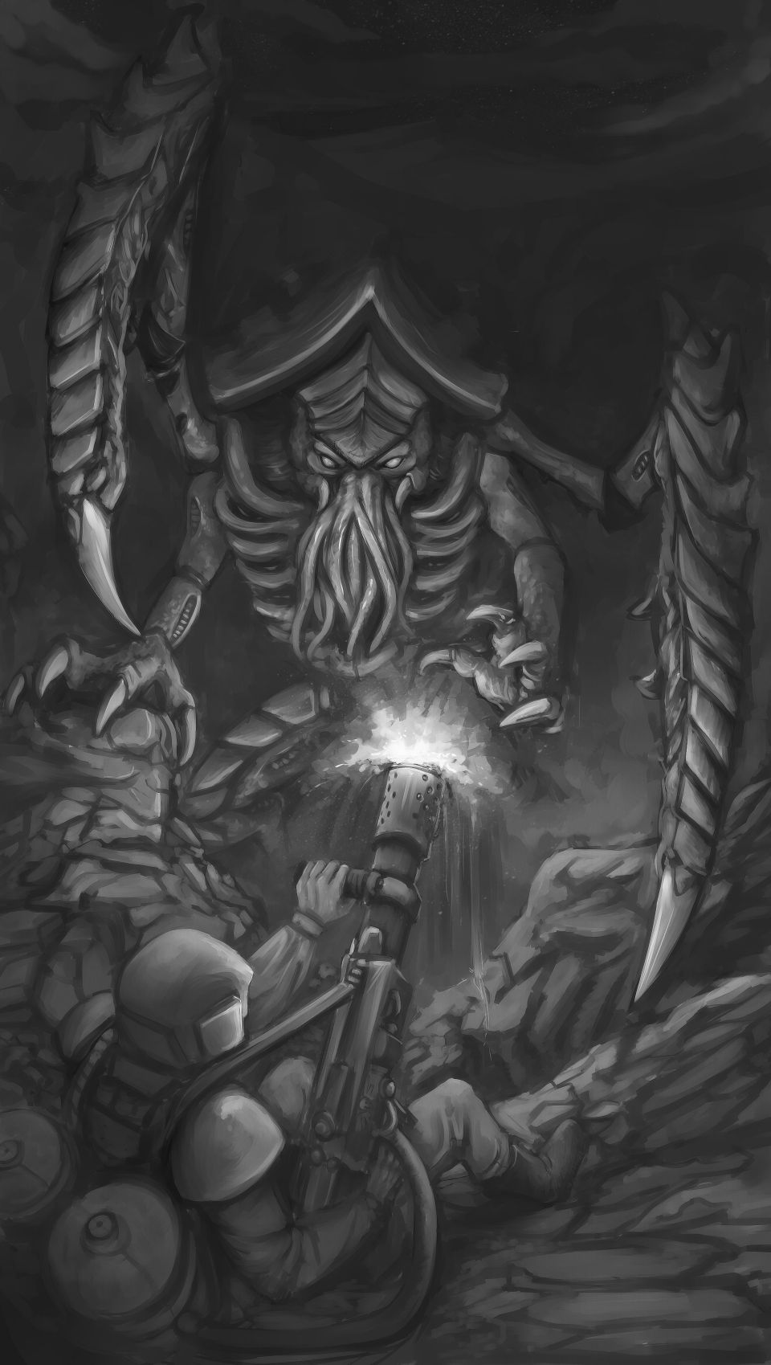
John and voss ran threw the jungle as faster as thay could . The creature that was chasing them was getting closer and closer with every second .thay both turned around with there guns drawn. Thay opened fired into the the dence brush hoping to hit or kill what ever the creature was mowing down the trees and brush .for a few seconds thay emptied half there ammo " did we hit it " said voss " as thay bother looked into the destroyed trees as John said " I don't think we did look no blood no body". A twig snapped and thay both turned towards the noise with there fingers on the triggers as thay scanned the foliage for movement. As John was about to lower his gun a splash of blood hit the side if his face as he turned his head vozz was gone all thay was left of him was his gun and a trail of blood leading deep into the jungle. John called out for voss and for a few second he waited till he heard a horrible scream about 80ft in the direction of the trail " iam comeing buddy hang on " as John dashed towards the scream as fast as his legs could carry him .as he got to a clearing he found voss well what was left of him his skull have multiple holes in it and his body looked withered like a dried rasin .John scanned the area high and low for signs of this creature but all that was out there was dark jungle and a setting sun .John new if he stayed here he would meet the same fate so he ran as fast as he could for about a hour till he found a massive hallowed out stump perfect for defense he though to himself as he claimed into the stump and aimed his gun and the opening ready for what ever it was to attack him .for hours and hours bother happened not a sound or enything till it was midnight he heard something .another twig snap he readied his gun as he could here what ever this monster was it was close .he jumped as something was dragging its claws against the back of the stump his heart pounding harder and faster (edited)….

